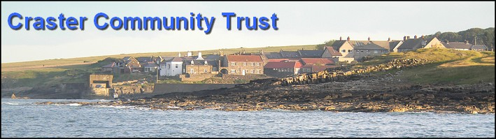

CRASTER COMMUNITY TRUST AGENDA
Meeting of Trustees
Thursday 27th January 2011 Memorial Hall 7pm

- Apologies  - Minutes of last meeting  - Matters arising  - Summary of special meeting MG  - Christmas Bingo HP  - Charity boxes and labels RR  - Treasurers report JR  - Discussion of where to invest the NWL monies and how the money should be spent, JS  - Administrative matters JS Future Structure of the CCT – role of sub committees and frequency of meetings  - Projects  - Memorial Hall  - Report re alternative proposals for kitchen RR  - Organisation of Public Meeting on 31st Jan JS  - Other Matters relating to the Hall MF  - Play Park  - Report on progress of repairs KB  - Discussion of report on meeting with Playdale MG  - Other matters relating to the civil parish of Craster and its surrounding area  - Ceilidh RG  - Beetle Drive HP  - Easter Bingo HP  - AOB [In writing before the meeting please]  Craster Community Web site  Funding Advisory meeting  Meeting ends | 7.00  7.05  7.10  7.20  7.25  7.35  7.45  8.00  8.10  8.15  8.20  8.25  8.30

